1. Which are the top three variables in your model which contribute most towards the probability of a lead getting converted?

Solution:

Based on the coefficient values from below screeshot, the following are the top three variables that contribute most towards the probability of a lead getting converted :

1. What is your current occupation_Housewife
2. Lead Source_Welingak Website
3. Lead Source_Reference
4. Lead Source_Olark Chart
5. Total Time spent on website

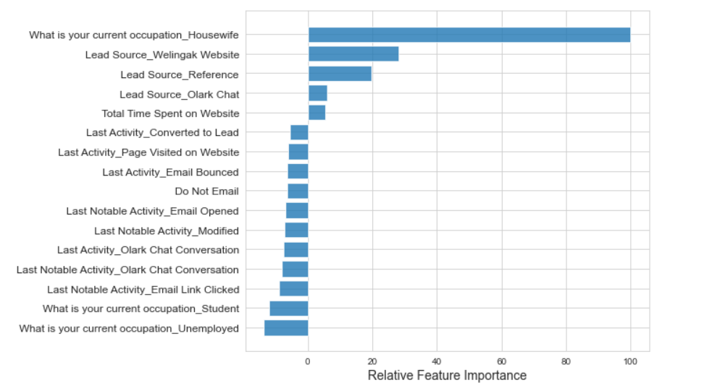

1. What are the top 3 categorical/dummy variables in the model which should be focused the most on in order to increase the probability of lead conversion?

Solution:

Based on the coefficient values, the following are the top three categorical/dummy variables that should be focused the most in order to increase the probability of lead conversion :

1. What is your current occupation_Housewife
2. Lead Source_Reference
3. Lead Source_Welingak Website
4. X Education has a period of 2 months every year during which they hire some interns. The sales team, in particular, has around 10 interns allotted to them. So, during this phase, they wish to make the lead conversion more aggressive. So, they want almost all of the potential leads (i.e., the customers who have been predicted as 1 by the model) to be converted and hence, want to make phone calls to as much of such people as possible. Suggest a good strategy they should employ at this stage.

Solution:

Phone calls must be done to people if:

• They spend a lot of time in the website and this can be done by making the website interesting and thus bringing them back to the site.

• They are seen coming back to the website repeatedly

• Their last activity is through SMS or through Olark chat conversation

• They are working Students or unemployed prospect customers.

1. Similarly, at times, the company reaches its target for a quarter before the deadline. During this time, the company wants the sales team to focus on some new work as well. So during this time, the company’s aim is to not make phone calls unless it’s extremely necessary, i.e. they want to minimize the rate of useless phone calls. Suggest a strategy they should employ at this stage.

Solution:

In this condition they need to focus more on other methods like automated emails and SMS. This way calling won’t be required unless it is an emergency. The above strategy can be used but with the customers that have a very high chance of buying the course.